Renee Ammerman

ITON1748

9/29/20

Lab 6

1. Yum, Systemctl – I typed “systemctl status httpd” to verify the web server was running, the status showed that it is running. I typed “yum list installed” and found the package “httpd-manual.noarch” to verify it was installed. I then switched to root user and used “yum remove httpd-manual.noarch” to remove the package.

I typed “ls -la /etc/httpd/conf.d” to view the contents of the directory. I then typed “yum install httpd-manual.noarch” to install the manual, and used “ls –la /etc/httpd/conf.d” to view the directory again, this time there was a manual.conf file. I typed in the given URL and the manual displayed.

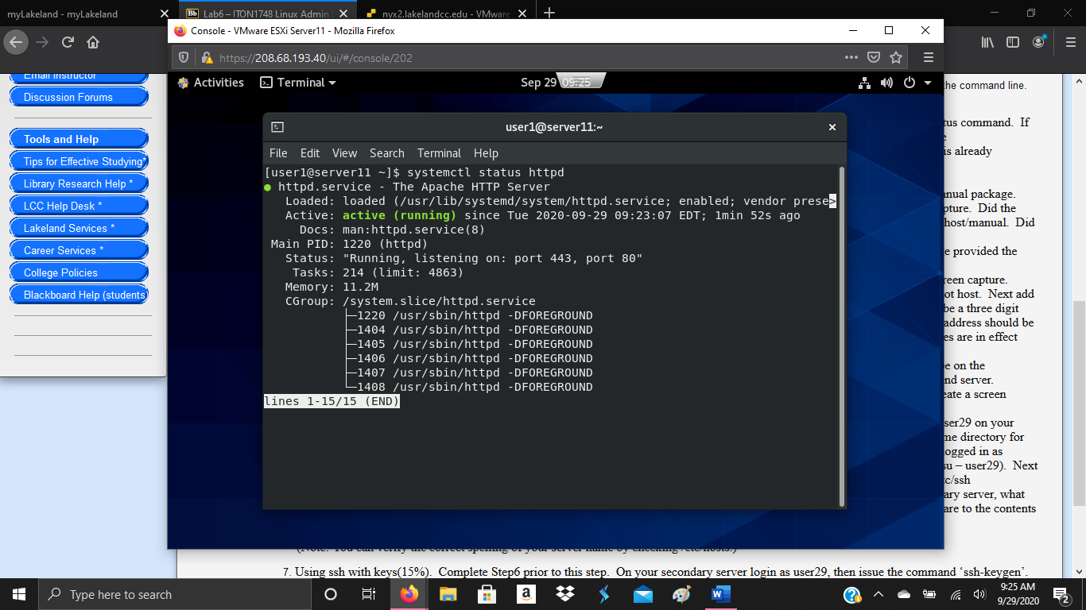

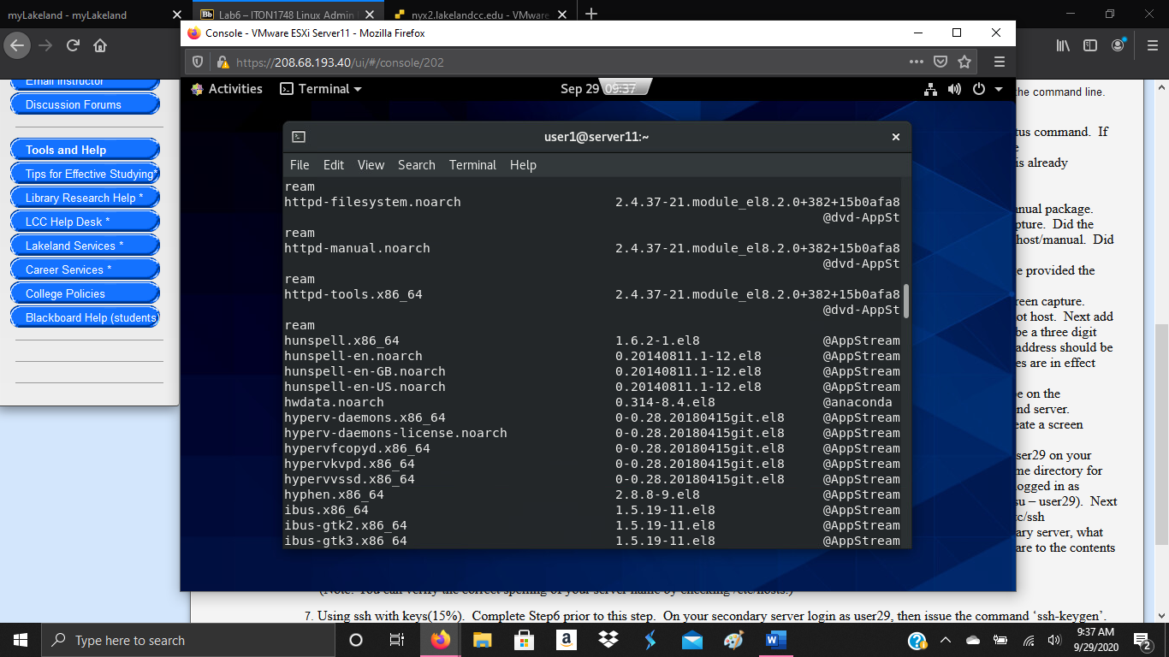

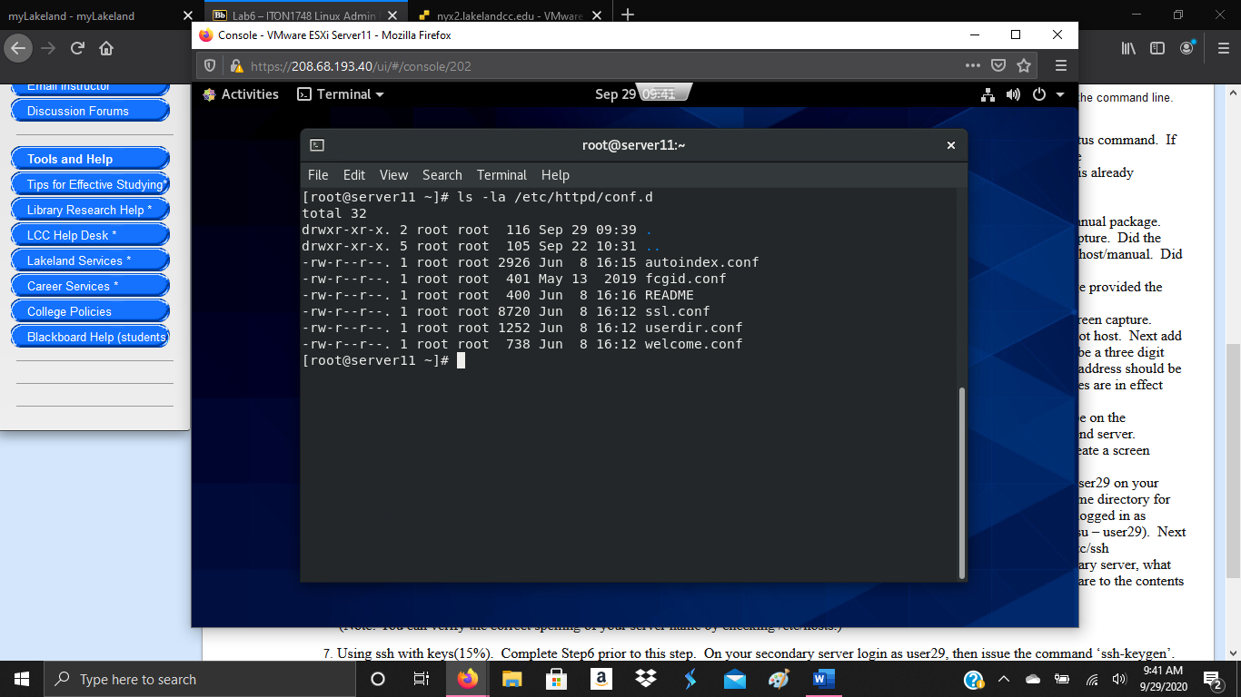

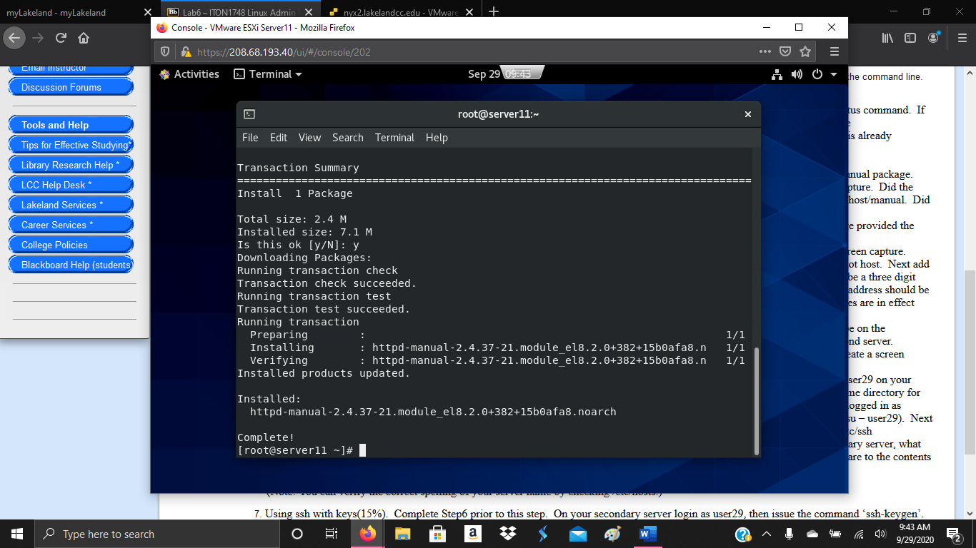

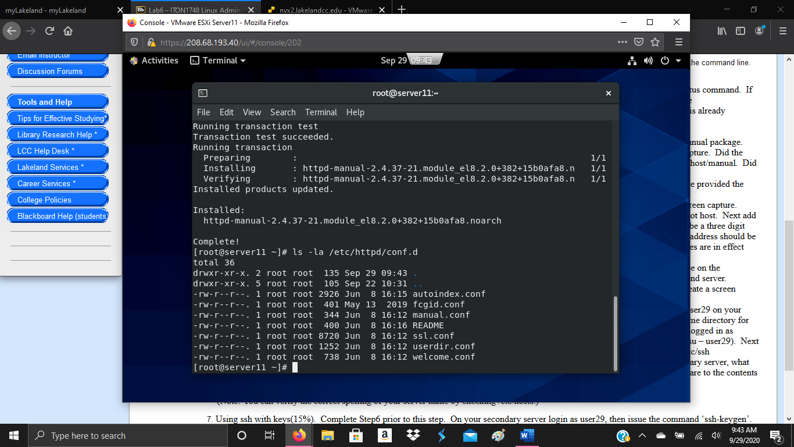

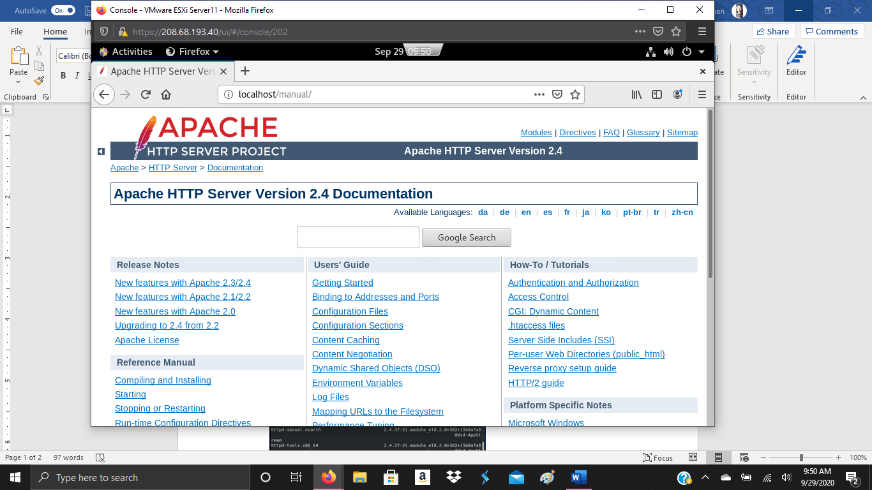

1. Search using Yum- I typed “yum provides ip ping traceroute” and found that the commands were located in the “dvd-BaseOS” repository.

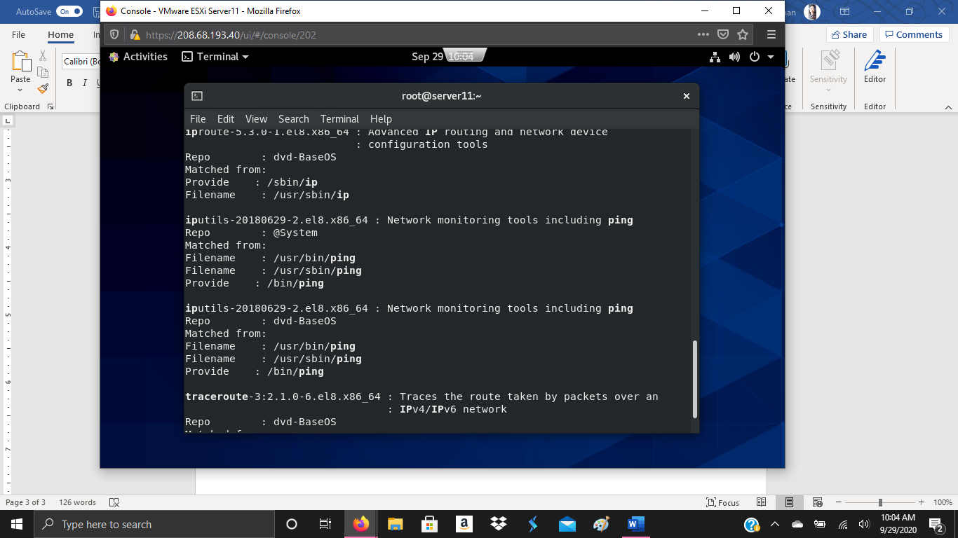

1. Ip, nmtui, nmcli- I typed “ifconig” to view the address and subnet mask. My server is on network ens192. I used “nmtui” to add the address “172.16.4.111” to the network. I typed “ip addr” to confirm it was added to the network.

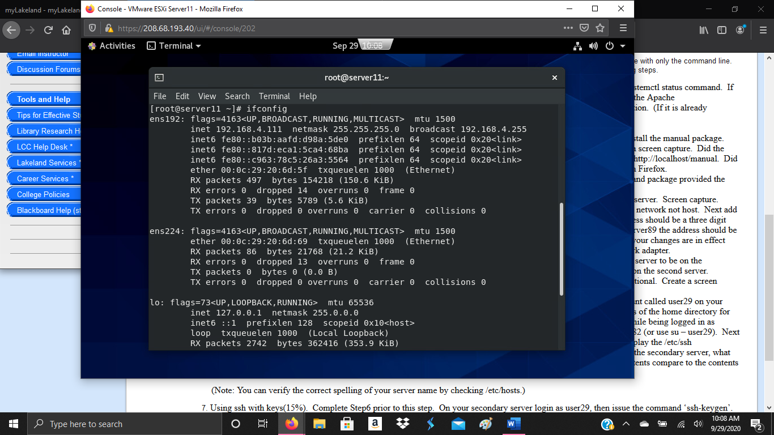

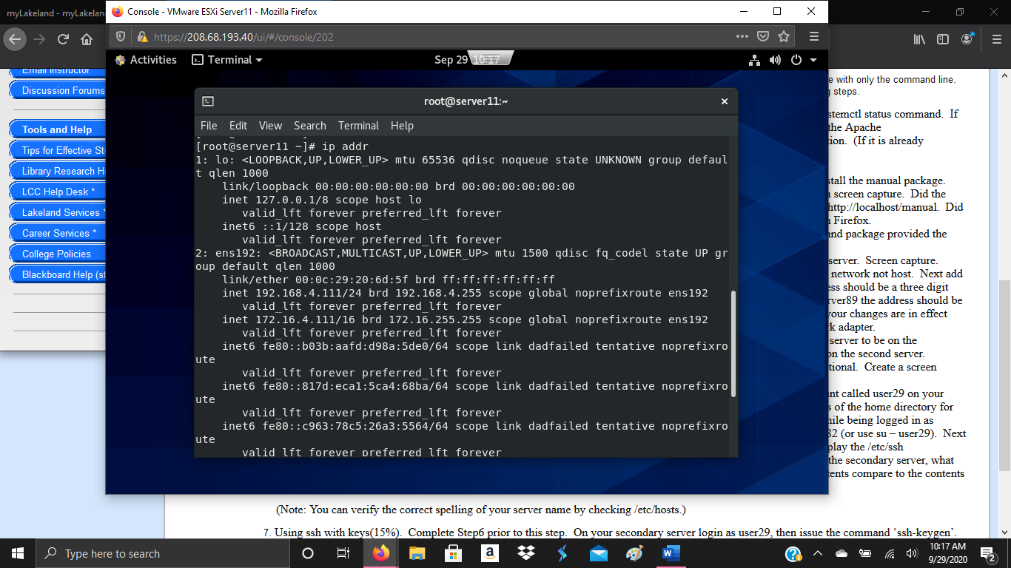

1. Ip, nmtui, nmcli- I typed “ssh root@server12” to switch to server12 and used “nmtui” to add the address “172.16.4.112” to the network. I typed “ip addr” to confirm it was added to the network.

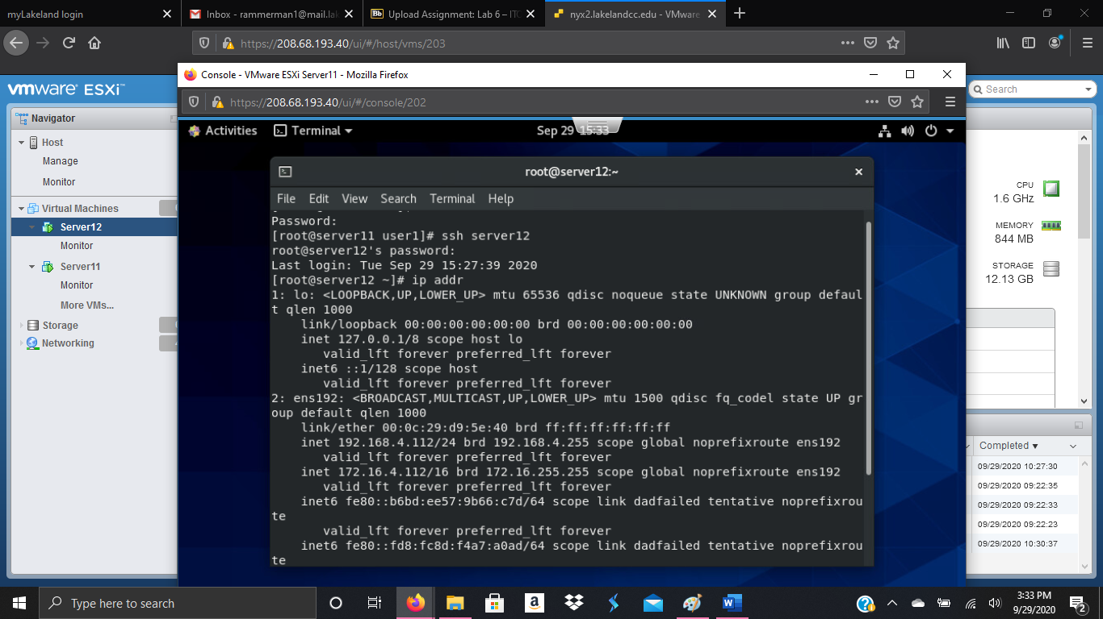

1. Ping/traceroute – I typed “ping server11” to ping server11. I used “tracepath” to view the path to 172.16.4.1.

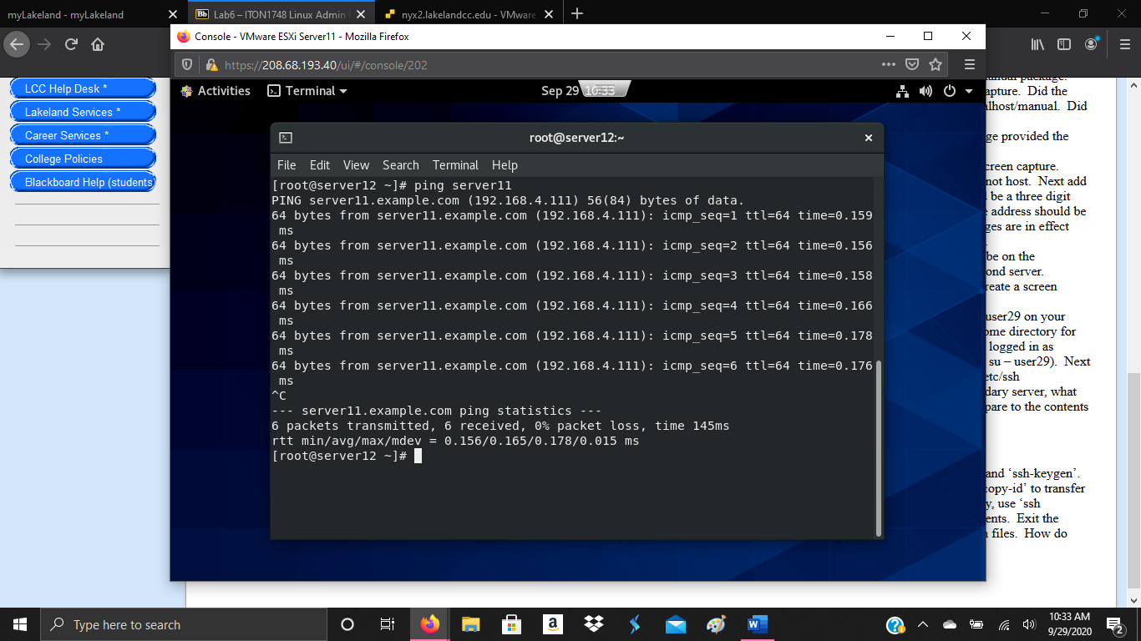

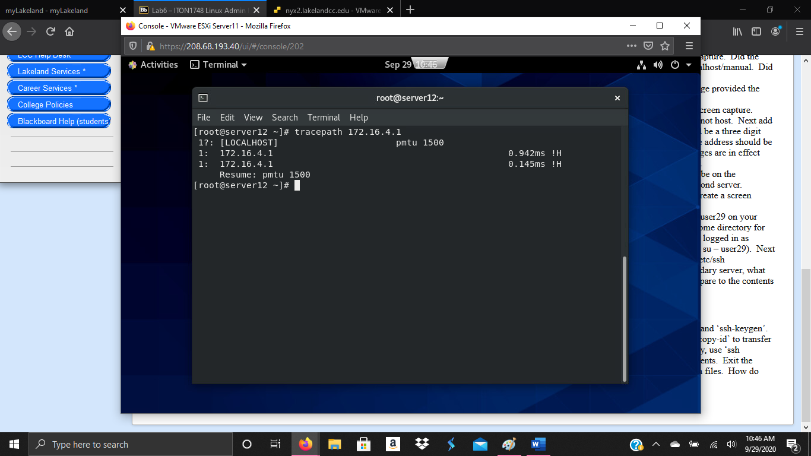

1. Ssh and user add- While on server12 I added “used29” using useradd. I switched back to server11 and added user19 using the same method. I switched to server12 and logged in as user29. I then used “ssh user19@server11” to login from server12 user29. I used the cat command to view the specific file. On the secondary server, the file known_hosts was created. The content of both files are the same key.

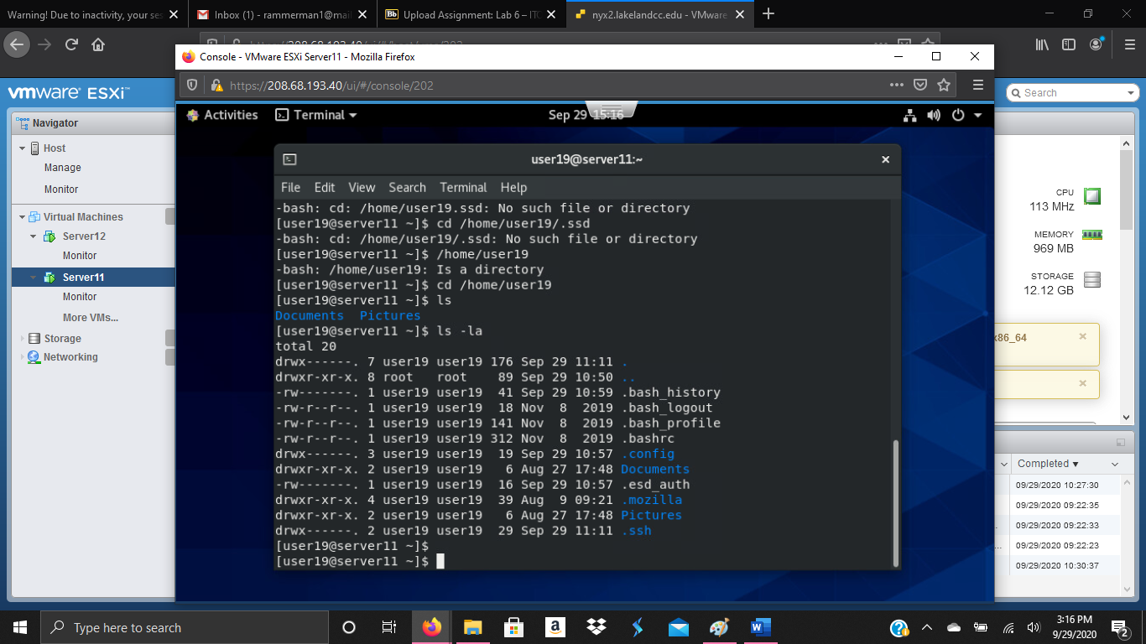

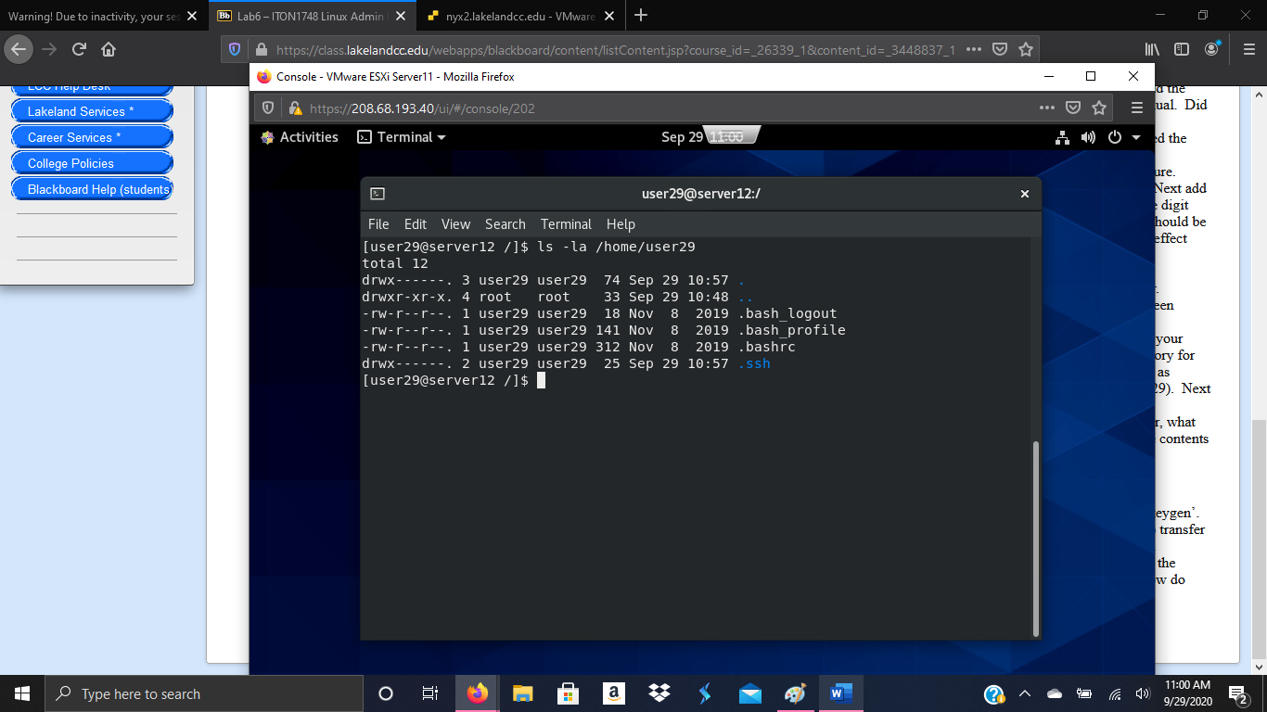

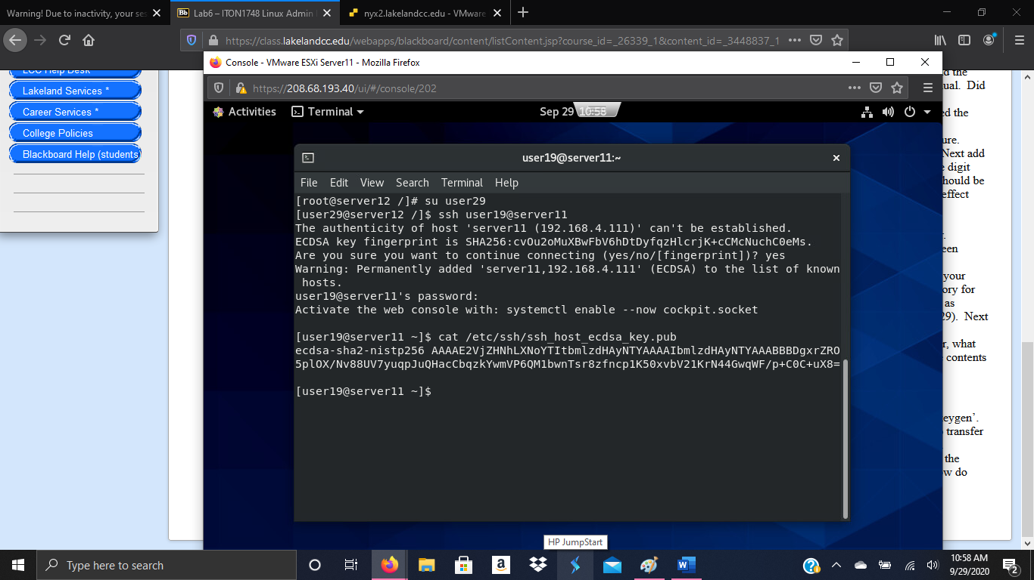

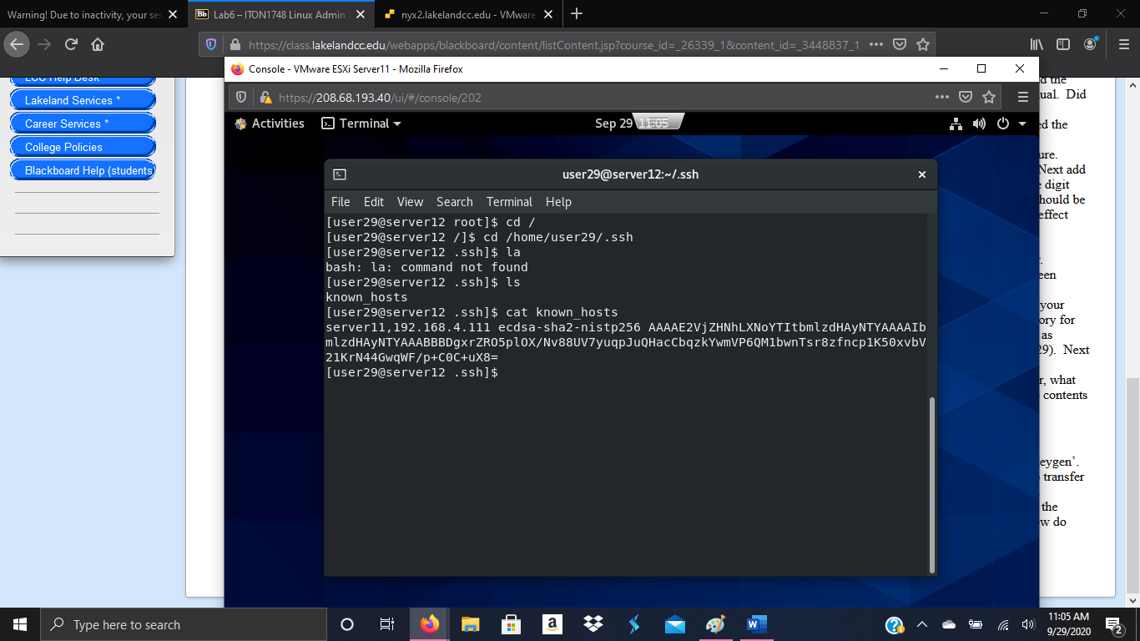

1. I used the command “ssh-keygen” while logged in as user29 on server12. The files created are “id_rsa” and “id_rsa.pub”. I typed “ssh-copy-id user19@server11”, I logged in using “ssh user19@server11”. The file added to the /.ssh directory was “authorized _keys”. The cat command on the “authorized_keys” and the “id_rsa.pub” files showed that both files contained the same text. When I tried “ssh” or “ssh-copy-id” with no user, the user account selected was the same I was already on but on the other server. Since I tried it from “user29@server12”, when I tried “ssh” with no user, the default was “user29@server11”.

